HTML Script Element

📘 Definition
# Source: AI Source: Provided by: [Data Path: Persons Table -> ID Column: 1, Name_En Column: Motasem Essam] -> From: [ChatGPT] on [5/6/2026]
The <script> element is used to add JavaScript code to an HTML page.
It allows you to make your webpage interactive and dynamic.

🎯 Interactive Vs Dynamic

🖱️ 1. Interactive

📖 Meaning:
# Source: AI Source: Provided by: [Data Path: Persons Table -> ID Column: 1, Name_En Column: Motasem Essam] -> From: [ChatGPT] on [5/6/2026]
A webpage is interactive when the user can do something and the page responds.
👉 There is user action → immediate response

🧠 Example of Interactive
# Source: AI Source: Provided by: [Data Path: Persons Table -> ID Column: 1, Name_En Column: Motasem Essam] -> From: [ChatGPT] on [5/6/2026]
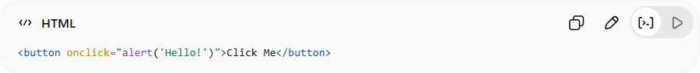
<button onclick="alert('Hello!')">Click Me</button>
👉 What happens:
- User clicks the button
- Page responds with a message
✔ User is involved
✔ Action triggers reaction

🔍 More interactive examples
# Source: AI Source: Provided by: [Data Path: Persons Table -> ID Column: 1, Name_En Column: Motasem Essam] -> From: [ChatGPT] on [5/6/2026]
- Clicking a button
- Filling a form
- Hovering over elements
- Playing a video

⚡ 2. Dynamic

📖 Meaning:
# Source: AI Source: Provided by: [Data Path: Persons Table -> ID Column: 1, Name_En Column: Motasem Essam] -> From: [ChatGPT] on [5/6/2026]
A webpage is dynamic when its content changes automatically or programmatically, not fixed like static HTML.
👉 Content is generated or updated, often without reloading the page

🧠 Example of Dynamic
# Source: AI Source: Provided by: [Data Path: Persons Table -> ID Column: 1, Name_En Column: Motasem Essam] -> From: [ChatGPT] on [5/6/2026]
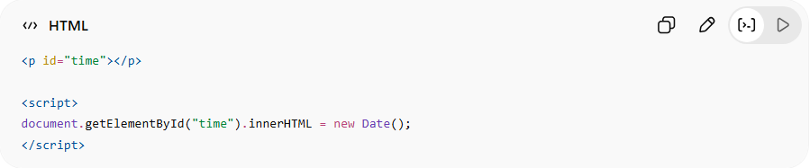
<p id="time"></p>
<script>
document.getElementById("time").innerHTML = new Date();
</script>
👉 What happens:
- Page shows current time
- Content is generated by JavaScript
✔ Changes over time
✔ Not hardcoded

🔍 More dynamic examples
# Source: AI Source: Provided by: [Data Path: Persons Table -> ID Column: 1, Name_En Column: Motasem Essam] -> From: [ChatGPT] on [5/6/2026]
- Live clock ⏰
- Loading new data from server 🌐
- Updating content without refresh
- Showing/hiding elements automatically

⚖️ Key Difference
# Source: AI Source: Provided by: [Data Path: Persons Table -> ID Column: 1, Name_En Column: Motasem Essam] -> From: [ChatGPT] on [5/6/2026]
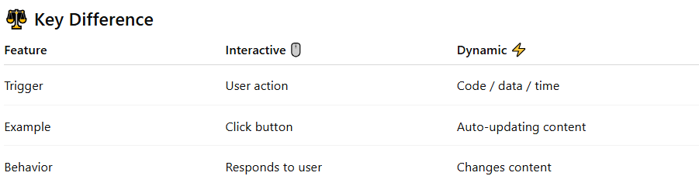
Feature | Interactive 🖱️ | Dynamic ⚡
Trigger | User action | Code / data / time
Example | Click button | Auto-updating content
Behavior | Responds to user | Changes content

Trigger:
# Source: AI Source: Provided by: [Data Path: Persons Table -> ID Column: 1, Name_En Column: Motasem Essam] -> From: [ChatGPT] on [5/6/2026]
In this context, a trigger is the thing that starts or causes something to happen.
👉 Think of it as:
“What makes the action happen?”

🖱️ Trigger in Interactive
# Source: AI Source: Provided by: [Data Path: Persons Table -> ID Column: 1, Name_En Column: Motasem Essam] -> From: [ChatGPT] on [5/6/2026]
Trigger = User action
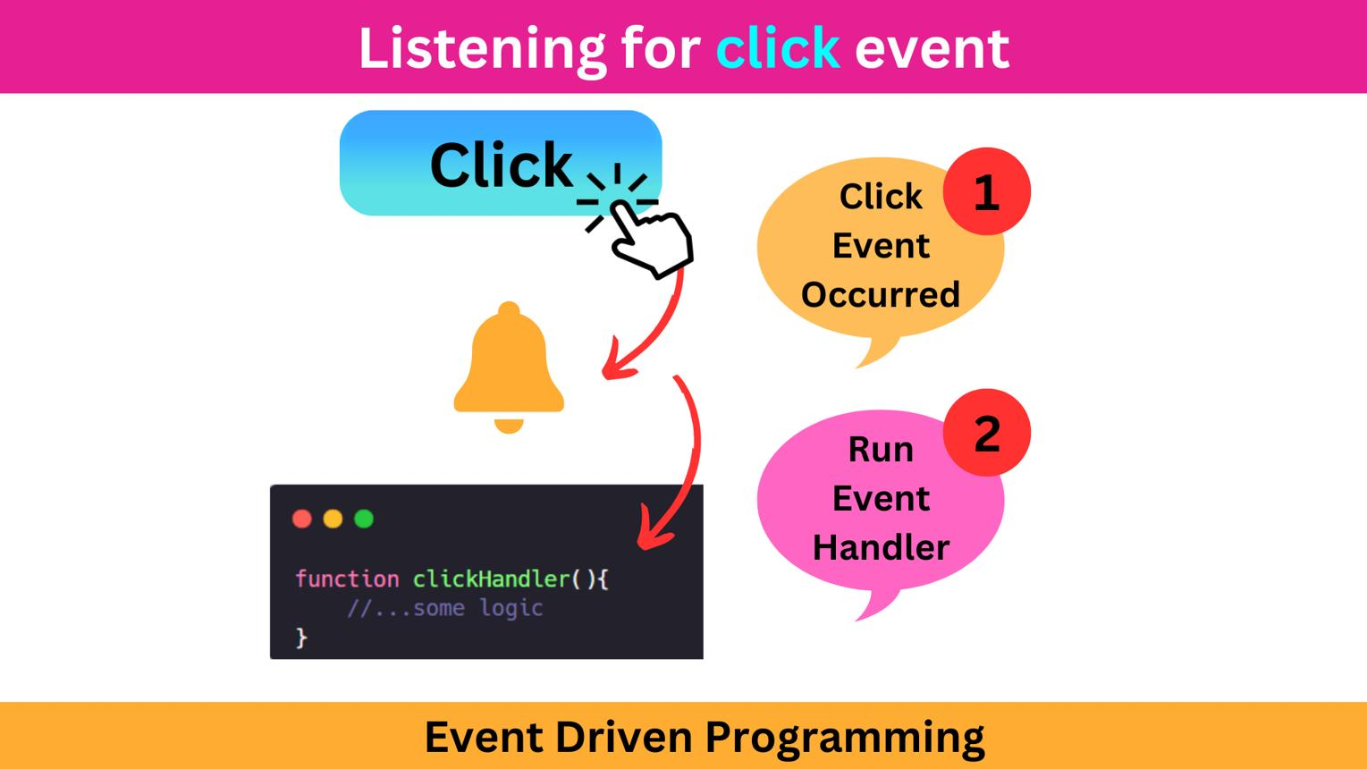
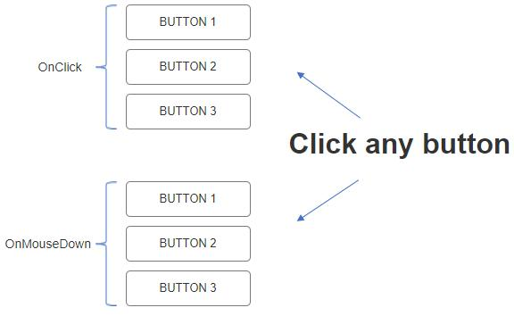
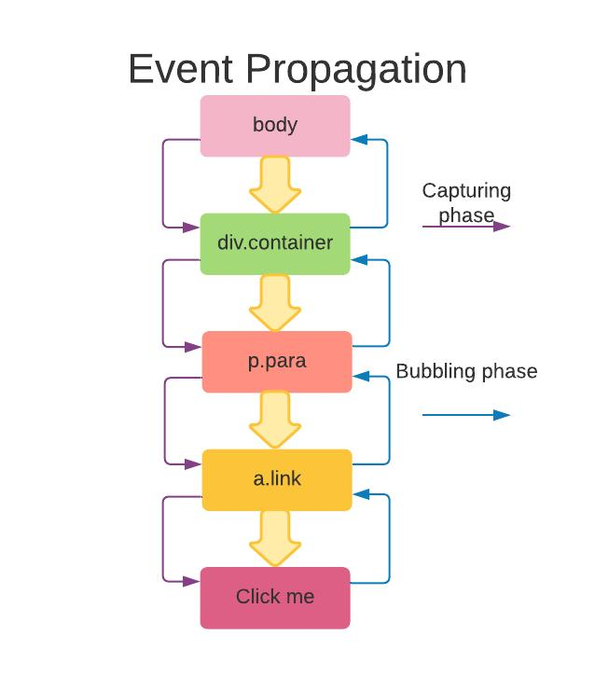
🧠 Example:
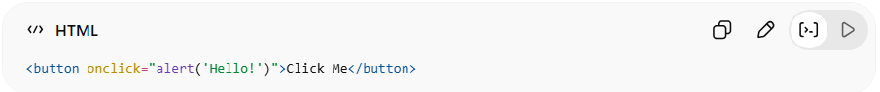
<button onclick="alert('Hello!')">Click Me</button>
👉 Trigger = user clicks the button
👉 Result = alert appears
✔ Trigger comes from the user

⚡ Trigger in Dynamic
# Source: AI Source: Provided by: [Data Path: Persons Table -> ID Column: 1, Name_En Column: Motasem Essam] -> From: [ChatGPT] on [5/6/2026]
Trigger = Code / system / data
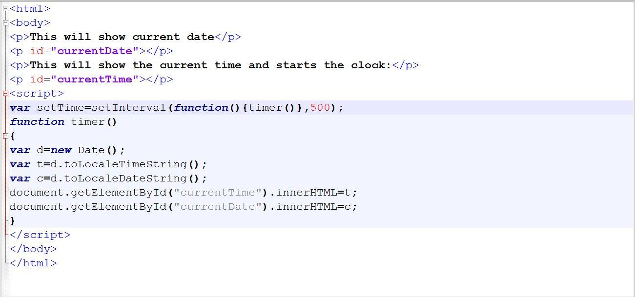
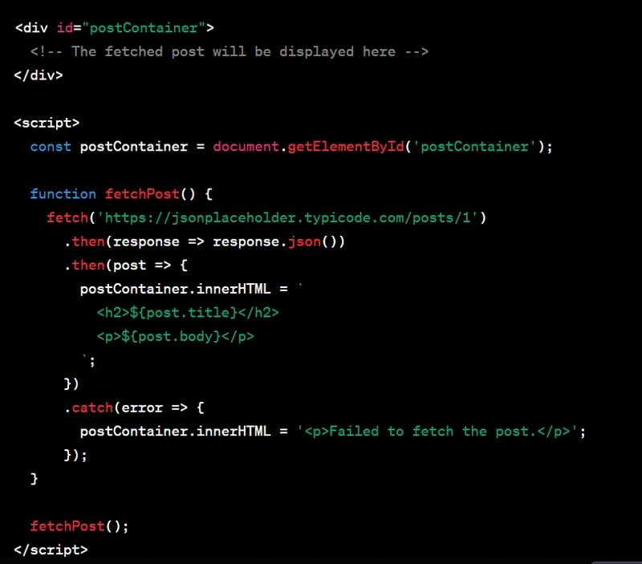
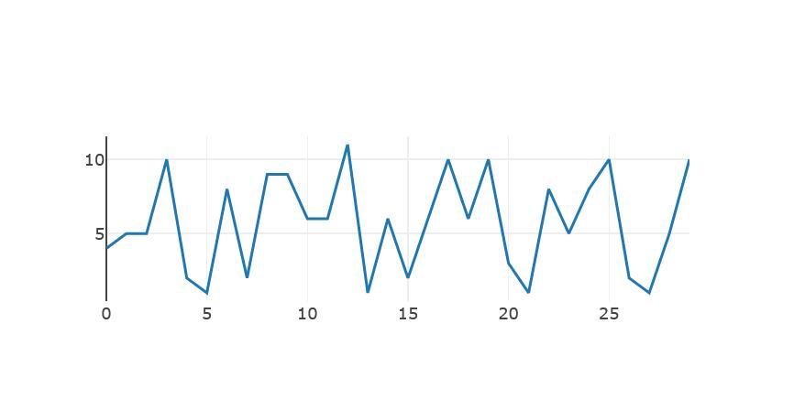
🧠 Example:
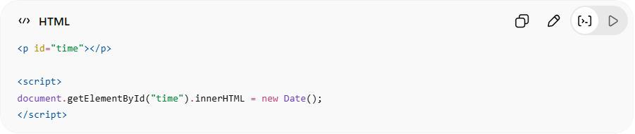
<p id="time"></p>
<script>
document.getElementById("time").innerHTML = new Date();
</script>
👉 Trigger = JavaScript code runs automatically
👉 Result = time appears
✔ Trigger comes from the system/code, not the user

⚖️ Simple comparison
# Source: AI Source: Provided by: [Data Path: Persons Table -> ID Column: 1, Name_En Column: Motasem Essam] -> From: [ChatGPT] on [5/6/2026]
- 🖱️ Interactive trigger → user does something
- ⚡ Dynamic trigger → system/code does something

🧠 Simple analogy
# Source: AI Source: Provided by: [Data Path: Persons Table -> ID Column: 1, Name_En Column: Motasem Essam] -> From: [ChatGPT] on [5/6/2026]
- 🔫 “Trigger” like in a tool:
→ You press it → something happens
- 🎮 In websites:
→ Click / load / data → something happens

🚀 Final Answer
# Source: AI Source: Provided by: [Data Path: Persons Table -> ID Column: 1, Name_En Column: Motasem Essam] -> From: [ChatGPT] on [5/6/2026]
Trigger = the event or action that causes something to happen on a webpage.

🧠 Simple analogy
# Source: AI Source: Provided by: [Data Path: Persons Table -> ID Column: 1, Name_En Column: Motasem Essam] -> From: [ChatGPT] on [5/6/2026]
- 🎮 Interactive = you press a button → game reacts
- 📺 Dynamic = content changes automatically (like live TV)

🚀 Final Answer
# Source: AI Source: Provided by: [Data Path: Persons Table -> ID Column: 1, Name_En Column: Motasem Essam] -> From: [ChatGPT] on [5/6/2026]
- Interactive = user controls the page
- Dynamic = the page updates or changes content automatically

⚙️ How <script> works
# Source: AI Source: Provided by: [Data Path: Persons Table -> ID Column: 1, Name_En Column: Motasem Essam] -> From: [ChatGPT] on [5/6/2026]
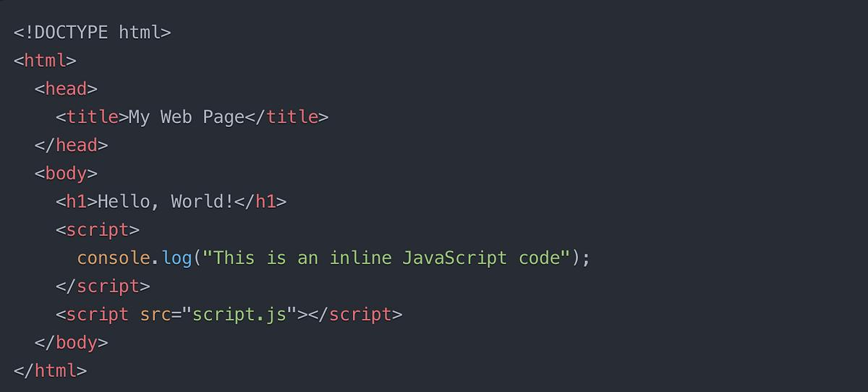
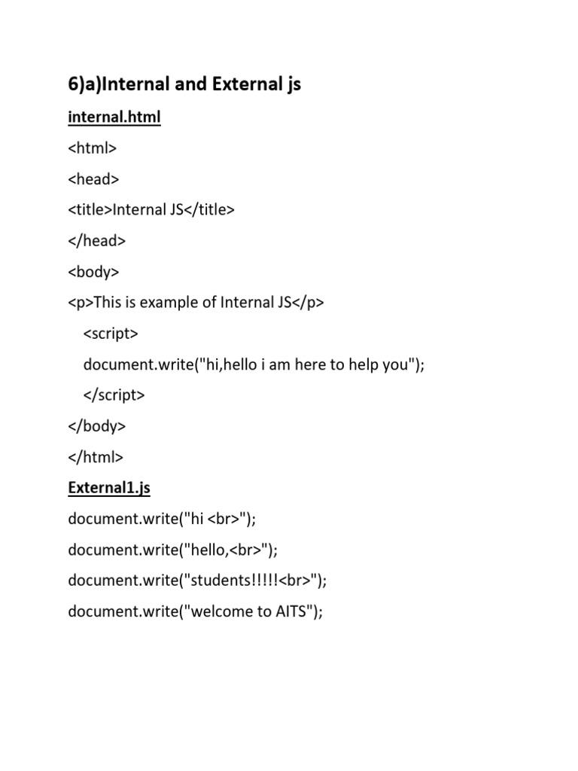
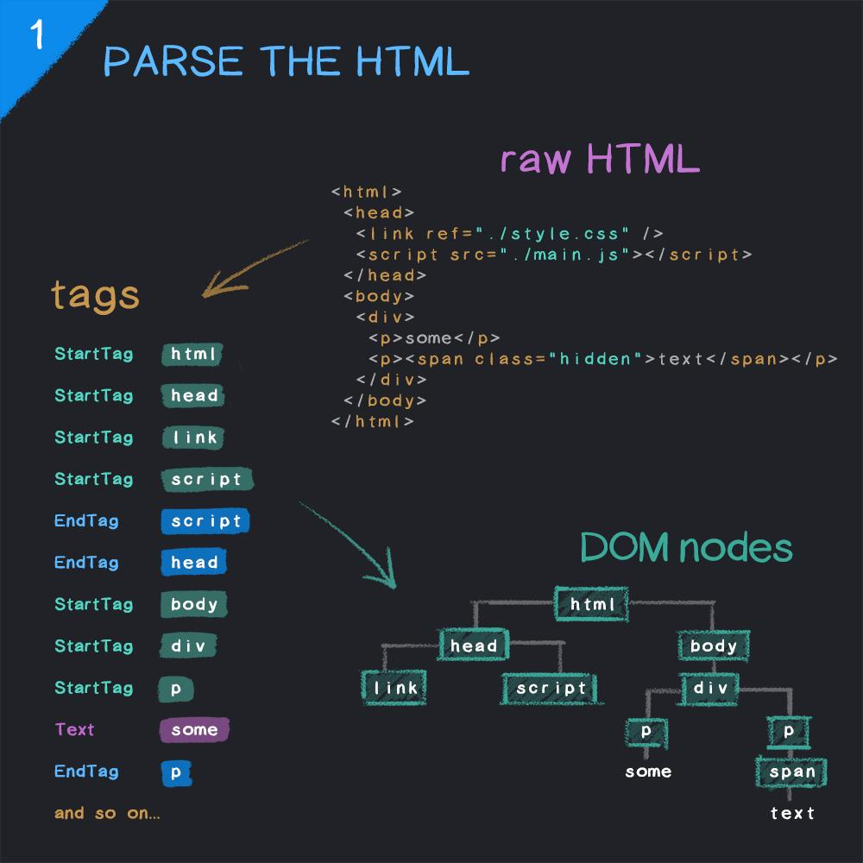
- The browser reads HTML
- When it finds <script>, it executes JavaScript
- JavaScript can change content, style, or behavior

🧪 Common Uses of <script> (with examples)

🟢 1. Internal JavaScript
# Source: AI Source: Provided by: [Data Path: Persons Table -> ID Column: 1, Name_En Column: Motasem Essam] -> From: [ChatGPT] on [5/6/2026]
📖 Description:
Write JavaScript directly inside the HTML file.
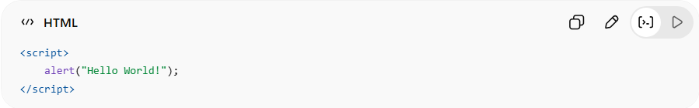
<script>
alert("Hello World!");
</script>
👉 Shows a popup message when the page loads

Full Example
# Source: AI Source: Provided by: [Data Path: Persons Table -> ID Column: 1, Name_En Column: Motasem Essam] -> From: [ChatGPT] on [5/6/2026]
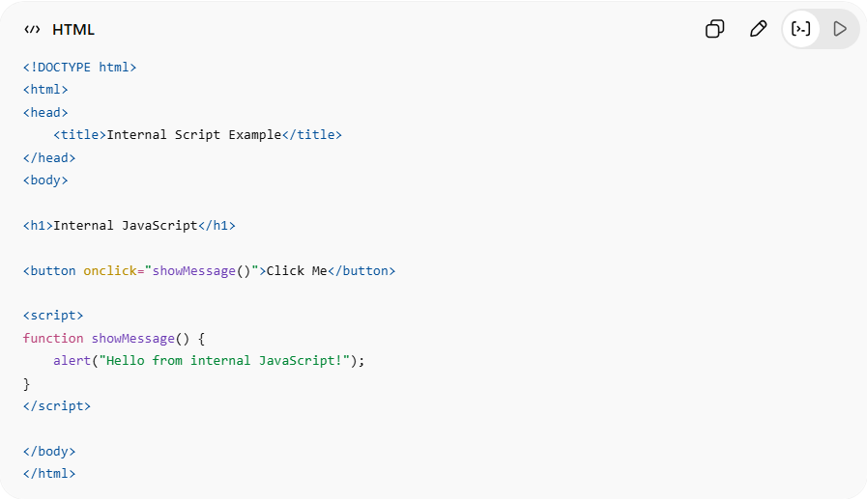
<!DOCTYPE html>
<html>
<head>
<title>Internal Script Example</title>
</head>
<body>

<h1>Internal JavaScript</h1>

<button onclick="showMessage()">Click Me</button>

<script>
function showMessage() {
alert("Hello from internal JavaScript!");
}
</script>

</body>
</html>

Real Example
# Source: ScreenShots Source: Provided by: [Persons Table -> ID Column: 1, Name_En Column: Motasem Essam] -> Tool: [Lightshot Program] -> From [Operating System: Windows] on [5/3/2026]
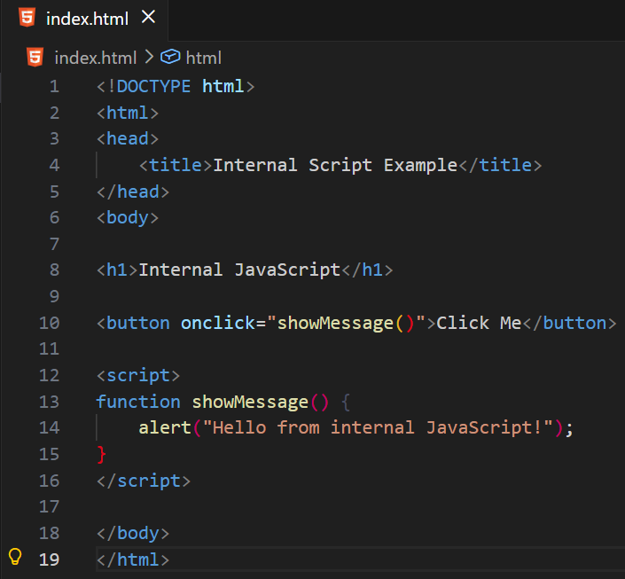
<!DOCTYPE html>
<html>
<head>
<title>Internal Script Example</title>
</head>
<body>

<h1>Internal JavaScript</h1>

<button onclick="showMessage()">Click Me</button>

<script>
function showMessage() {
alert("Hello from internal JavaScript!");
}
</script>

</body>
</html>

🟡 2. External JavaScript File
# Source: AI Source: Provided by: [Data Path: Persons Table -> ID Column: 1, Name_En Column: Motasem Essam] -> From: [ChatGPT] on [5/3/2026]
📖 Description:
Link a separate .js file (best practice).
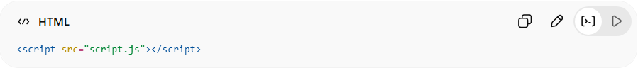
<script src="script.js"></script>
script.js
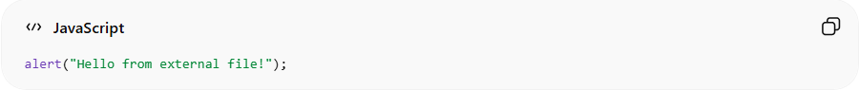
alert("Hello from external file!");
👉 Keeps HTML clean and organized

🔵 3. Script in <head> vs <body>
# Source: AI Source: Provided by: [Data Path: Persons Table -> ID Column: 1, Name_En Column: Motasem Essam] -> From: [ChatGPT] on [5/3/2026]
❌ In <head> (can block loading)
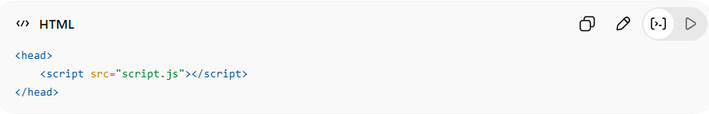
<head>
<script src="script.js"></script>
</head>
✅ At end of <body> (recommended)
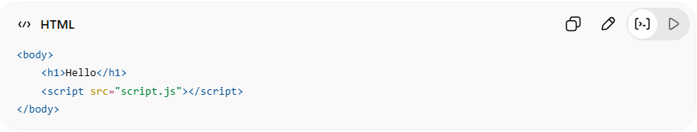
<body>
<h1>Hello</h1>
<script src="script.js"></script>
</body>
👉 Loads page first, then runs script

🟣 4. Using defer (Best Practice)
# Source: AI Source: Provided by: [Data Path: Persons Table -> ID Column: 1, Name_En Column: Motasem Essam] -> From: [ChatGPT] on [5/3/2026]
📖 Description:
Loads script in background and runs after HTML is ready.
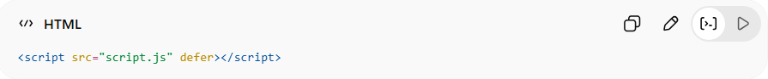
<script src="script.js" defer></script>
👉 Best for performance and clean loading

🟠 5. Using async
# Source: AI Source: Provided by: [Data Path: Persons Table -> ID Column: 1, Name_En Column: Motasem Essam] -> From: [ChatGPT] on [5/3/2026]
📖 Description:
Loads and runs script independently (faster but unordered).
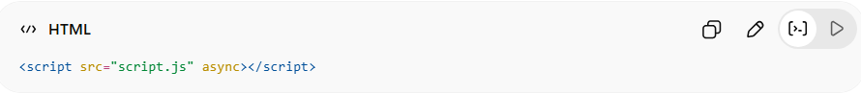
<script src="script.js" async></script>
👉 Good for analytics or ads

🔴 6. JavaScript Interaction Example
# Source: AI Source: Provided by: [Data Path: Persons Table -> ID Column: 1, Name_En Column: Motasem Essam] -> From: [ChatGPT] on [5/3/2026]
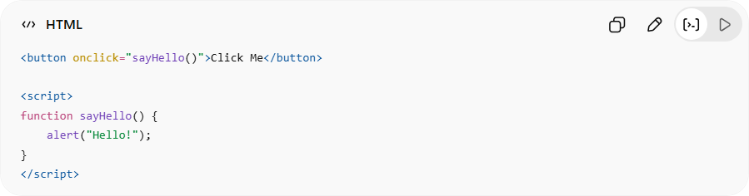
<button onclick="sayHello()">Click Me</button>
<script>
function sayHello() {
alert("Hello!");
}
</script>
👉 Adds interactivity to webpage

⚠️ Common Mistakes
# Source: AI Source: Provided by: [Data Path: Persons Table -> ID Column: 1, Name_En Column: Motasem Essam] -> From: [ChatGPT] on [5/3/2026]
❌ Missing src file:
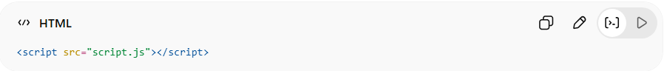
<script src="script.js"></script>
(if file doesn't exist → error)
❌ Blocking page loading:
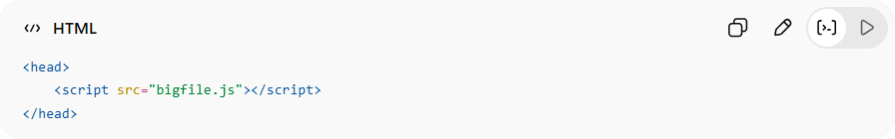
<head>
<script src="bigfile.js"></script>
</head>

⚙️ Key Features
# Source: AI Source: Provided by: [Data Path: Persons Table -> ID Column: 1, Name_En Column: Motasem Essam] -> From: [ChatGPT] on [5/3/2026]
- 💻 Runs JavaScript in browser
- ⚡ Makes pages interactive
- 🔗 Can link external files
- 🎯 Controls behavior of webpage

🚀 In short:
# Source: AI Source: Provided by: [Data Path: Persons Table -> ID Column: 1, Name_En Column: Motasem Essam] -> From: [ChatGPT] on [5/3/2026]
<script> = the HTML element used to run JavaScript and make webpages interactive.

